**cal command:**

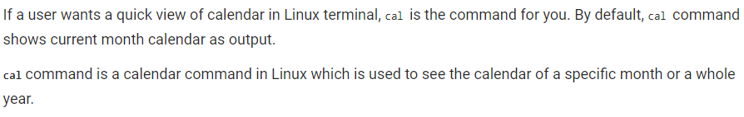

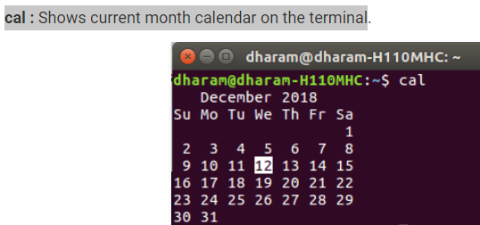

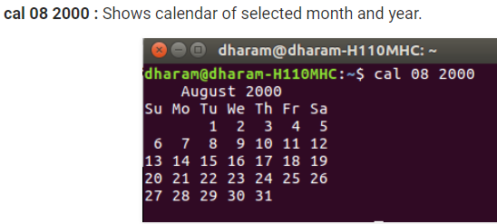

**cal 2018:** Shows the whole calendar of the year

**cal -3:** Shows calendar of previous, current and next month

**cal -h:** do not highlight the current date

**cal -y:** Display this entire year's calendar.

**cal -y 2000:** Display the entire year 2000 calendar.

**cal 2000:** Same as the previous command.

**cal -m December or cal -m Dec or cal -m 12 or cal 12:** Display the calendar for December of this year.

**cal 12 2000:** Display the calendar for December, 2000.

**ncal:**

**ncal:** Display this month's calendar, with weeks arranged vertically rather than horizontally.

**ncal -y:** Use a vertical calendar representation, displaying the entire year.